https://mkyong.com/java/how-to-read-xml-file-in-java-dom-parser/

Xml file exemple :

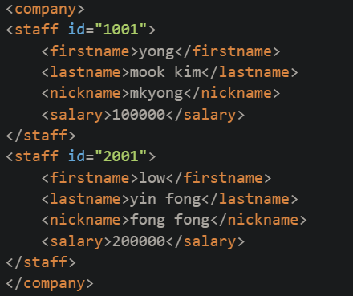

Code that fetchs data :

import javax.xml.parsers.DocumentBuilderFactory;

import javax.xml.parsers.DocumentBuilder;

import org.w3c.dom.Document;

import org.w3c.dom.NodeList;

import org.w3c.dom.Node;

import org.w3c.dom.Element;

import java.io.File;

public class ReadXMLFile {

public static void main(String argv[]) {

try {

File fXmlFile = new File("/Users/mkyong/staff.xml");

DocumentBuilderFactory dbFactory = DocumentBuilderFactory.newInstance();

DocumentBuilder dBuilder = dbFactory.newDocumentBuilder();

Document doc = dBuilder.parse(fXmlFile);

//optional, but recommended

//read this - http://stackoverflow.com/questions/13786607/normalization-in-dom-parsing-with-java-how-does-it-work

doc.getDocumentElement().normalize();

System.out.println("Root element :" + doc.getDocumentElement().getNodeName());

NodeList nList = doc.getElementsByTagName("staff");

System.out.println("----------------------------");

for (int temp = 0; temp < nList.getLength(); temp++) {

Node nNode = nList.item(temp);

System.out.println("\nCurrent Element :" + nNode.getNodeName());

if (nNode.getNodeType() == Node.ELEMENT_NODE) {

Element eElement = (Element) nNode;

System.out.println("Staff id : " + eElement.getAttribute("id"));

System.out.println("First Name : " + eElement.getElementsByTagName("firstname").item(0).getTextContent());

System.out.println("Last Name : " + eElement.getElementsByTagName("lastname").item(0).getTextContent());

System.out.println("Nick Name : " + eElement.getElementsByTagName("nickname").item(0).getTextContent());

System.out.println("Salary : " + eElement.getElementsByTagName("salary").item(0).getTextContent());

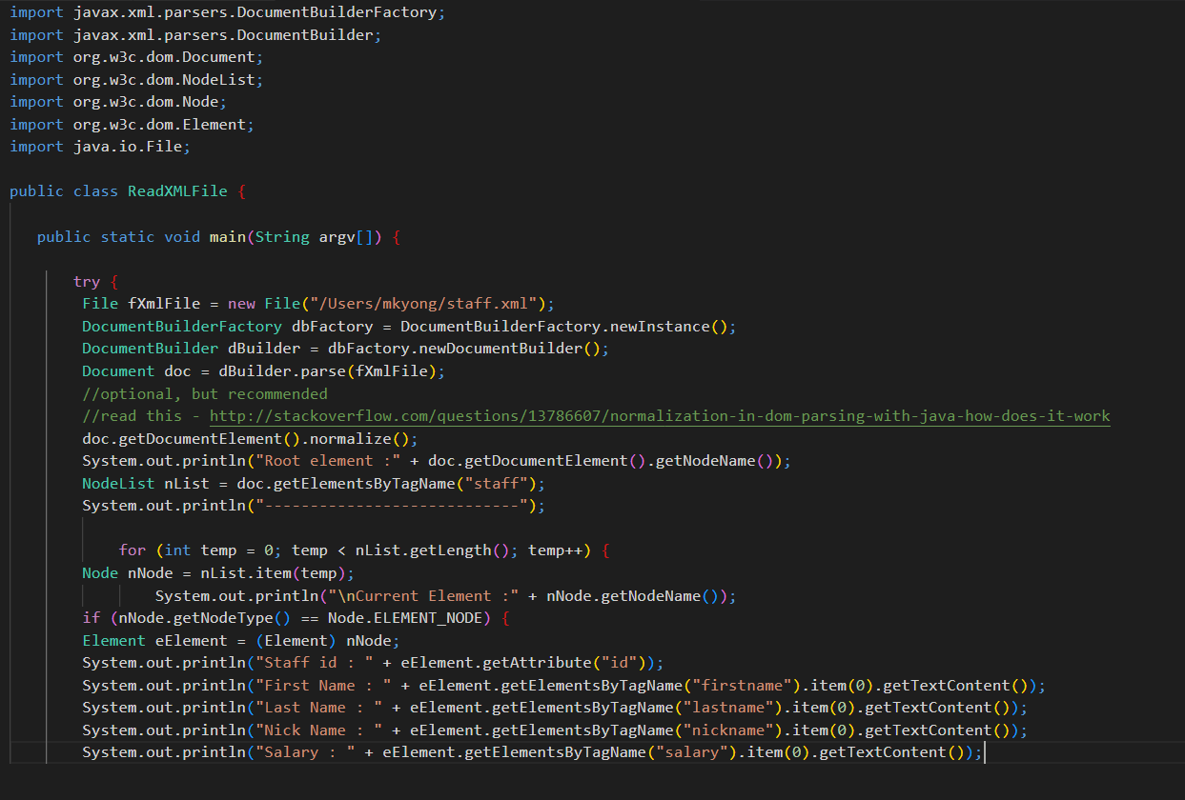

.normalize() : 